Draft Multicultural Policy 2016-20

April 2016
This policy was compiled by Hobsons Bay City Council for reference purposes only. For further information contact Hobsons Bay City Council on 9932 1000 or visit www.hobsonsbay.vic.gov.au
Council acknowledges all language groups of the Kulin Nation as the traditional owners of these municipal lands. We recognise the first people’s relationship to this land and offer our respect to their elders past and present.
Council also acknowledges the legal responsibility to comply with the Charter of Human Rights and Responsibilities Act 2006 and the Equal Opportunity Act 2010.

Contents
Mayor’s message 4
Introduction 5
Community profile 7
What you told Council 11
Legislative and policy context 13
Council’s role 14
Hobsons Bay policy context 15
Goals and objectives 16
Implementation 19
Monitoring and evaluation 20
Human rights compliance 21

Mayor’s message
Welcome to the Multicultural Policy 2016-20.
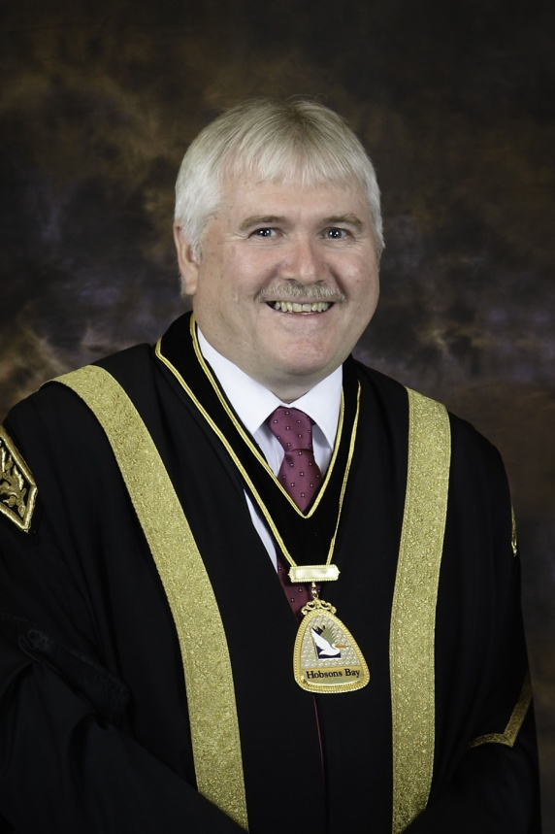
Hobsons Bay has a rich and proud history of cultural diversity which emerged through the 1950s and ‘60s and continues to the present day.
More than 30 per cent of our residents were born overseas, with three-quarters of these (more than 19,000 people) from a non-English speaking background. Trends like these will continue in the coming years as more people from culturally and linguistically diverse backgrounds call Hobsons Bay home, each with their own distinctive cultural traditions, histories and needs.
People from culturally and linguistically diverse backgrounds have made substantial contributions to the local community, making Hobsons Bay the great place it is today. It is important that as a community we respect each other’s backgrounds, and I encourage you to reach out to your neighbours, have a conversation and proudly share your history.
As a Council, we aim to ensure that all of our services, programs and facilities are accessible for all community members. The Multicultural Policy 2016-20 will continue to see Council strive for this goal. Throughout this journey, we encourage your input into how Council can be more inclusive of culturally and linguistically diverse communities.
I would like to thank everyone who participated in the development of the Multicultural Policy 2016-20. I look forward to the continued celebration and sharing of Hobsons Bay’s unique cultural diversity.
Councillor Peter Hemphill
Mayor of Hobsons Bay 2015-16

Introduction
The Multicultural Policy 2016-20 provides Council and the community with the following vision:
Hobsons Bay is a welcoming and multicultural community which provides opportunities and a sense of belonging for people of all cultural, linguistic and religious backgrounds.
People from culturally and linguistically diverse backgrounds bring important strengths to Hobsons Bay including new skills, knowledge and experiences. However, they also experience barriers such as reduced access to educational, economic, social, recreational and civic opportunities.
Culturally and linguistically diverse communities are an asset for Hobsons Bay, making it a more interesting and vibrant place. Council recognises that it is critical to protect and promote our cultural diversity and continue to build a welcoming community for all.

Purpose
Informed by research and community consultation, the purpose of the Multicultural Policy 2016-20 is to:
- articulate Council’s role in:
  - leading, partnering and supporting activities to promote respect for cultural diversity
  - recognising and celebrating cultural traditions
  - providing improved access to social, economic and civic opportunities
- provide a framework for culturally responsive activities within all areas of Council, including planning, advocacy, service and facility provision, community engagement, information provision and organisational development
- build on the achievements of the Multicultural Policy 2012-15, which include the establishment of the Hobsons Bay Language Line, Racism. It Stops With Me campaign and Hobsons Bay Settlement Network

Principles
The following principles underpin how Council will work towards achieving the vision of the Multicultural Policy 2016-20:
- Respect and value - all cultural and linguistically diverse communities deserve respect and to be valued for what they bring to Hobsons Bay
- Difference and diversity – all cultural and linguistically diverse communities have their own individual and collective identities, histories, traditions and needs
- Equity and access – some people from culturally and linguistically diverse backgrounds need additional and specific support to access economic, social, and civic opportunities
- Leadership and partnership - Council will lead by example and work with others to reach shared goals

Methodology
To ensure the Multicultural Policy 2016-20 responds to the needs of culturally and linguistically diverse communities in Hobsons Bay, it has been developed in three stages:
- Research - a comprehensive background paper was prepared to commence the policy review process and guide the subsequent consultation and policy development stages
- Consultation - targeted consultation was undertaken to identify strengths, key issues and suggestions for how Council and the community can be more accessible and welcoming for people from culturally and linguistically diverse backgrounds
- Policy development - a draft policy was developed based on research and consultation results, tested with internal and external stakeholders, before being finalised and adopted by Council

Figure 1: Development of the Multicultural Policy 2016-20
The following supporting resources have been produced to inform the development of the Multicultural Policy 2016-20:
- Multicultural Policy 2016-20 Background Paper
- Multicultural Policy 2016-20 Consultation Report
- Multicultural Policy 2016-20 Consultation Film
- Multicultural Policy 2016-20 Policy Summary (also available in nine community languages)
All resources are available on Council’s website or by contacting Council on 9932 1000.

Community profile
The City of Hobsons Bay covers an area of 65 square kilometres, extending seven to 20 kilometres south-west of Melbourne’s central business district. In 2014, the population was just over 91,000 and is forecast to grow steadily to around 100,000 by 2025.

People
Hobsons Bay is home to people from over 130 different countries. Almost 31 per cent of the population was born overseas, with more than three-quarters of this group (over 19,000 people) from a non-English speaking background. A further 6,000 Australian born people identify with a non-English speaking ancestry.
The most common overseas birthplaces in Hobsons Bay are the United Kingdom, India, Italy, New Zealand and Vietnam. Between 2006 and 2011, the biggest increase came from Indian born residents, whose population more than tripled. Hobsons Bay also has comparatively large Maltese and Lebanese communities.
Hobsons Bay residents speak more than 100 different languages. The most common languages other than English are Arabic, Italian, Greek, Vietnamese and Maltese. Mandarin, Karen and several Indian languages have grown rapidly in recent years. At least five per cent of the population (more than 4,400 people) do not speak English well or at all.

Place
Prior to European settlement, the Yalukit Wilum clan occupied the area now known as Hobsons Bay. Today, it is home to the suburbs of Altona, Altona Meadows, Altona North, Brooklyn, Laverton, Newport, Seabrook, Seaholme, South Kingsville, Spotswood, Williamstown and Williamstown North.
Laverton, Brooklyn and Altona North have the highest proportions of overseas born people, each in excess of 40 per cent of the local population. Laverton also has the highest percentage of residents from a non-English speaking background (39%), with this group almost doubling in size between 2006 and 2011. Hobsons Bay’s largest neighbourhood, Altona Meadows, has the highest number of overseas born residents (more than 6,500 people).
The development of the Multicultural Policy 2016-20 was informed by a detailed demographic analysis presented in the Multicultural Policy 2016-20 Background Paper. The paper is available on Council’s website or by contacting Council on 9932 1000.

Infographics
The following data is represented in the format of infographics.

People
91,148 estimated resident population (2014)
31% of Hobsons Bay population was born overseas (over 25,000 people) with residents coming from more than 130 different countries
Top 5 Birthplaces
UK | 3,803
India | 2,333
Italy | 1,648
New Zealand | 1,624
Vietnam | 1,333
Birthplace (change from 06 to 11)
India | +1,639
China | +313
Burma/Myanmar | +190
Thailand | +162
Nepal | +97

23% of the Hobsons Bay population comes from non-English speaking countries (over 19,000 people)
135 Asylum seekers live in Hobsons Bay (as at September 2015)
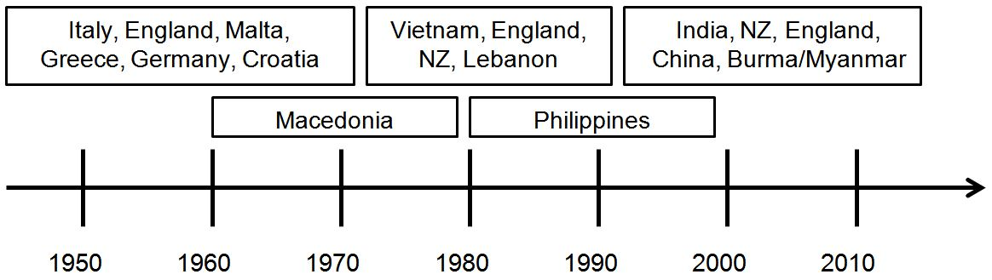
Religion
Roman Catholic | 31%
Anglican | 10%
Islam | 5%
Greek Orthodox | 5%
Uniting Church | 3%
Buddhism | 3%
Presbyterian | 2%
Hinduism | 2%
Baptist | 2%
Other | 15%
No religion | 22%
Aged 65 or above*
Italy | 64%
Greek | 58%
Maltese | 54%
Croatia | 44%
Germany | 42%
*minimum of 400 residents

Aged 25 or below*
India | 31%
New Zealand | 22%
China | 22%
Philippines | 21%
Lebanon | 14%
*minimum of 400 residents

Place
Residents born overseas
Laverton | 46%
Brooklyn | 40%
Altona North | 40%
Altona Meadows | 35%
Seabrook | 31%

Language
29% of Hobsons Bay population speak a language other than English at home (over 24,000 people) with residents speaking more than 100 different languages
Top 5 Languages
Arabic | 3,026
Italian | 2,734
Greek | 2,545
Vietnamese | 1,637
Maltese | 1,344
Language (change from 06 to 11)
Punjabi | +779
Hindi | +399
Mandarin | +357
Karen | +263
Gujarati | +160
5% of the population (over 4,400 people) speak another language but have low or no English proficiency
Language spoken by people who have low or no English proficiency
 | Persons
Greek | 531
Vietnamese | 501
Arabic | 469
Italian | 467
Cantonese | 275
Macedonian | 245
Mandarin | 229
Karen | 211
Maltese | 139
Serbian | 124
Croatian | 114
Other | 1,104
Total | 4,409

Study, Work and Home

Education
- Tertiary qualifications: 44% v 37% (overseas born vs Australian born in all cases)
- Completed Year 12 (or equivalent): 46% v 53%
- Did not attend school past Year 8 (or equivalent): 16% v 5%

Employment
- Employed (full time or part time): 43% v 62%
- Not in workforce: 39% v 29%

Gross Weekly Income
- $200 to $399: 26% v 17%
- $600 or higher: 35% v 52%

Housing
Renting house by birthplace*
Sudan | 88%
India | 76%
Mauritius | 60%
New Zealand | 60%
Sri Lanka | 52%
*minimum of 100 residents
Own/purchasing house by birthplace
Malta | 94%
Greece | 94%
Italy | 93%
Macedonia | 92%
Cambodia | 87%

What you told Council
Consultation was undertaken to help develop the Multicultural Policy 2016-20.
The numbers:
500+ people participated
38 birthplaces
12 Hobsons Bay suburbs
216 community survey responses
126 staff survey responses
42 interviews
13 focus groups
Targeted activities were provided to offer different ways for people to have their say, including focus groups, surveys, filmed interviews and online engagement.
Over 500 people participated from established communities, new and emerging communities, young people, women, service providers, faith leaders, the Council Multicultural Advisory Group, and Council staff.
The purpose of consultation was to identify:
- strengths of culturally and linguistically diverse communities and current service provision
- gaps, challenges and issues for culturally and linguistically diverse communities
- solutions to make Council and the community more accessible and welcoming for people from culturally and linguistically diverse backgrounds

Strengths
Hobsons Bay has many close-knit communities based around shared language, religious beliefs and settlement experiences. Other strengths include local networks of social and community groups, and a tradition of locally organised and supported cultural festivals and events. Council’s support for cultural celebrations, festivals, and services such as libraries and community grants, help culturally and linguistically diverse communities to maintain, share and develop these strengths.
“Council’s recognition of other cultural celebrations and educating the general public about the Indian culture is helpful. This is through having signs of the Diwali festival, similar to what was done for Christmas.”
Indian community focus group participant

Gaps, challenges and issues
Hobsons Bay’s culturally and linguistically diverse communities experience a number of gaps, challenges and issues which can reduce access to employment, education, housing, transport and community facilities. The community survey found that ‘finding a job’ (42%), ‘access to education’ (41%) and ‘access to transport’ (38%) were the most important issues for people from culturally and linguistically diverse backgrounds in Hobsons Bay. Language barriers also present a challenge for many different groups, especially asylum seekers, people from refugee backgrounds, and older people within established communities.
“I studied IT and was working in the banking IT department. But after spending nine months of being in Australia and finding a job, I eventually started work in a completely different field of hospitality as
I needed work.”
Chinese community focus group participant

Access to Council’s community consultation, communications and promotional material is a gap for some communities. People from culturally and linguistically diverse backgrounds often don’t know how to get involved in Council decision making processes, and rely on face-to-face conversations to fully understand the role of Council and how they can access Council services and facilities.
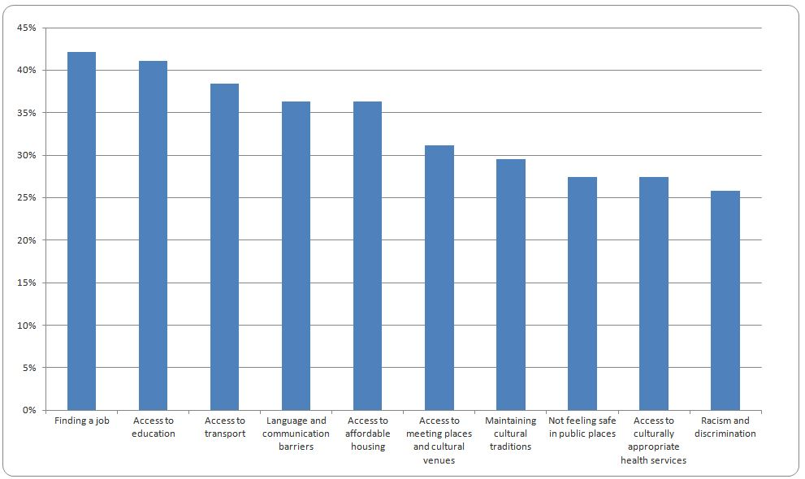
Figure 2: What issues are important to people from different cultures in Hobson Bay?
Source: Multicultural Policy 2016-20 Community Survey
While racism and discrimination was not a leading issue, it is important for some groups and can lead to significant challenges such as reduced perceptions of public safety for women and young people. Maintaining cultural traditions and involving young people in cultural celebrations and events is another challenge for some culturally and linguistically diverse communities.

Solutions
A number of activities, programs and processes can be put in place to continue to build an inclusive community. Access to employment can be supported in many ways, including through information sessions, mentoring programs, networking opportunities and promotion of support services. Access to education can be strengthened through homework support programs and English language classes.
Hobsons Bay can become more welcoming through activities focussed on cultural interaction and continued support for festivals and events. Community programs such as cross-cultural orientation mentoring programs, targeted sports and recreation programs, and mental health awareness workshops will also help to make Hobsons Bay more welcoming for people from culturally and linguistically diverse backgrounds.
“As we recruit new staff, we need to ensure we are recruiting people from culturally and linguistically diverse backgrounds to ensure we have a diverse workforce.”
Staff Survey response

Council can strengthen access through more consistent use of interpreters and translated information, more culturally and linguistically diverse staff and increased staff knowledge of different cultures. Council is currently implementing advocacy on key issues such as public transport, health services and affordable housing, and this work should continue as it will also greatly support culturally and linguistically diverse communities.
A detailed description of the consultation process is provided in the Multicultural Policy 2016-20 Consultation Report. A film has also been produced which documents the views of community members on several key consultation questions. All materials are available on Council’s website or by contacting Council on 9932 1000.

Legislative and policy context
International, Commonwealth and Victorian legislation and policy frameworks influence how Council plans for and works with culturally and linguistically diverse communities. The following legislation and policy is of particular importance to the development and implementation of the Multicultural Policy 2016-20.

International
Australia was a key player in drafting the Universal Declaration of Human Rights (1948), which states the basic rights and fundamental freedoms to which all people are entitled. Australia is also a party to the Convention Relating to the Status of Refugees (1951), which outlines the rights of refugees and the legal obligations of states towards refugees and asylum seekers.

Commonwealth
The Racial Discrimination Act 1975 defends the principle of equity before the law for people of all backgrounds, and prohibits discrimination on the basis of race or religion. The Australian Human Rights Commission Act 1986 established the Australian Human Rights Commission, which has the power to examine how the Commonwealth Government meets its human rights obligations.
The People of Australia (2011) is Australia’s multicultural policy, and supports the right to celebrate, practise and maintain cultural traditions within the law and free from discrimination. The National Anti-Racism Strategy (2012) focuses on public awareness, education resources and youth engagement to prevent racism and raise awareness of its impact on individuals and the community.
The Migration Amendment (Unauthorised Maritime Arrivals and Other Measures) Act 2013 introduced an amendment to the Migration Act 1958, which creates a separate process for asylum seekers arriving by boat. The Migration and Maritime Powers Legislation Amendment (Resolving the Asylum Legacy Caseload) Act 2014 introduces further changes, including reduced pathways to permanent protection for asylum seekers, reduced rights of appeal to the Refugee Review Tribunal, and the denial of citizenship to children born in Australia to asylum seeker parents.
Victorian
The Equal Opportunity Act 2010 is Victoria’s key anti-discrimination legislation, and outlaws public discrimination based on race and religious activity. The Multicultural Victoria Act 2011 established the Victorian Multicultural Commission and outlines seven principles of multiculturalism, including mutual respect and understanding, equal entitlement to opportunity, and shared commitment to Australia.
Victoria’s Advantage - Unity, Diversity and Opportunity (2014) is Victoria’s multicultural affairs and citizenship policy. It aims to maximise the benefits of cultural diversity, promote citizenship, participation and social cohesion, and support accessible and responsive service delivery. The Strategic Framework to Strengthen Victoria’s Social Cohesion and the Resilience of its Communities (2015) identifies key policy priorities to guide funding allocation and alignment of initiatives to strengthen social cohesion and community resilience, and prevent violent extremism.
The development of the Multicultural Policy 2016-20 was informed by a detailed review of the legislative and policy context, presented in the Multicultural Policy 2016-20 Background Paper. The paper is available on Council’s website or by contacting Council on 9932 1000.

Council’s role
Under the Local Government Act 1989, councils must aim to ‘ensure that services and facilities provided by the Council are accessible and equitable’ (s.3C). The role of local government also includes ‘fostering community cohesion and encouraging active participation in civic life’ (s.3D).
As the closest level of government to the community, Council plays an important leadership role and is well placed to identify, understand and respond to the needs of local culturally and linguistically diverse communities. Council plays several other roles and often moves between these to best meet competing priorities, including as a:
- planner – participating in service coordination, policy development, consultation and research
- community capacity builder – working with people and organisations to develop new skills, build capacity and resilience, organise events, and promote access to opportunities
- service provider – delivering culturally appropriate services which support health and wellbeing
- resource provider – supporting communities through community grants and other funding opportunities, and the provision and maintenance of facilities
- partner and broker – facilitating, supporting and participating in local and regional partnerships to improve access to services and create new opportunities
- advocate and supporter – engaging with communities, stakeholders and governments to effect positive change in policy, processes and resource allocation
In addition, Council provides a range of other services and facilities including parks and open space, sports grounds, recreation centres, personal and home care, seniors centres, community workshops, library services, community centres, youth services, early years services, and cultural events and festivals.
Council faces many challenges in undertaking these roles and delivering services and facilities, including reduced funding from other levels of government, legislative and regulatory reforms, changing community needs, growing population, and the introduction of ‘rate capping’ from 2016-17. As such, Council cannot work alone and recognises that sustainable change requires ongoing partnerships with key stakeholders such as service providers, community leaders, employers, educational facilities, sport and recreation clubs, faith and community groups, and, of course, the community.

Hobsons Bay policy context
The Multicultural Policy 2016-20 sits within a hierarchy of other Council plans, policies and strategies.
Figure 3: Hobsons Bay City Council Policy Context
The Community Health and Wellbeing Plan 2013-17 is Council’s key strategic plan, and set outs the community’s vision, priorities and goals for improving health and wellbeing. The plan adopts a population health approach which aims to maintain and improve the health of the entire population, while also reducing health inequities experienced by some population groups such as culturally and linguistically diverse communities.
The Council Plan 2013-17 describes how Council will work to achieve the community’s vision and priorities, as set out in the Community Health and Wellbeing Plan. It informs the development of Council’s budget and other strategies, as well as the organisational structure, departmental business plans, resource allocation and staff work plans.
The Advocacy Strategy 2014-18 outlines where and how Council will focus its advocacy activities. It outlines thirteen priority areas including affordable housing, integrated transport, health services, mental heath services for young people, and employment and economic development.
The Multicultural Policy 2016-20 aims to align with the leading Council plans and articulate specific goals and objectives relating to culturally and linguistically diverse communities in Hobsons Bay. The Multicultural Policy 2016-20 works alongside other Council strategic policies to support cross organisational and integrated change.

Goals and objectives
The Multicultural Policy 2016-20 consists of three goal areas. These are further supported by objectives. An overview of the goal areas and objectives is provided on the following pages
Figure 4: Multicultural Policy 2016-20 Framework

Goal one: respect and celebrate cultural diversity

People of all backgrounds will be able to fully express their cultural identities and share their traditions with the community.
Cultural festivals and events create a strong sense of belonging within culturally and linguistically diverse communities. They also provide opportunities for the broader community to experience and learn about different cultural traditions.
Community consultation highlighted widespread support for multiculturalism in Hobsons Bay, although it also revealed that some people experience racism and discrimination. Racism and discrimination has led to a reduction in perceptions of public safety for groups such as Muslim women and Muslim young people. In some cases, young people also feel disempowered and disconnected from their own communities and wider society.
The physical environment can also influence how much people from culturally and linguistically diverse backgrounds ‘feel at home’, especially new and emerging communities. Culturally distinctive design elements, names of streets and parks, vegetation, recreation spaces, signs and building facades can all make people feel welcome. Recent UN research supports this notion, suggesting that incorporating cultural diversity into the development of public spaces and places promotes social inclusion, cultural dialogue and a sense of belonging.
Council does not tolerate or accept racism and discrimination in any form and will continue to welcome people from around the world. It will help to strengthen social cohesion by bringing people of all ages and backgrounds together to feel welcome, celebrate and share their cultural traditions.
Council will:
- Support activities which recognise and celebrate cultural traditions
- Provide opportunities to share and exchange cultural traditions to further build understanding across communities
- Lead initiatives to address racism and discrimination and promote the benefits of cultural diversity
- Provide and support public places and spaces that contribute to a sense of belonging for people of culturally and linguistically diverse backgrounds

Goal two: create and support opportunities

People of all cultural backgrounds will be able to access and participate in the opportunities required to enjoy a secure and healthy life.
Economic and social opportunities such as finding a job, attaining educational qualifications, and getting involved in volunteering or sport are critical to a secure and healthy life. People from diverse cultural and linguistic backgrounds have made substantial economic and social contributions to Hobsons Bay, including establishing local businesses, sporting clubs and social groups.
Consultation with people from culturally and linguistically diverse backgrounds, however, revealed that some communities also face barriers to accessing economic and social opportunities.
In relation to employment, the community identified numerous barriers such as limited recognition of overseas qualifications, difficulty understanding and speaking English, lack of mentors and networks, and discrimination on the basis of name, culture or religious background.
In relation to education, limited study assistance, low levels of parental engagement, and lack of awareness of education pathways were identified as key issues. Many of these employment, education and language barriers are experienced to a greater degree by new and emerging communities, young people, skilled migrants and people from refugee backgrounds.
In relation to social opportunities, the community highlighted the need for more local and affordable sport, arts and volunteering activities.
Settlement, health and family support services also play a critical role in supporting people to access opportunities. They provide tailored programs especially for vulnerable groups (such as women, young people and older people) through activities which address specific needs including housing, language, mental health, family violence and transport.
Council will:
- Work with local employers and other stakeholders to support employment and business pathways for people from culturally and linguistically diverse backgrounds
- Provide and support activities to improve access to education and employment opportunities through English language, mentoring, leadership and learning programs
- Work with community organisations and service providers to enhance settlement, health and family support for people from culturally and linguistically diverse backgrounds
- Provide and support inclusive opportunities for people to feel socially connected through sport, recreation, arts, environmental and volunteering programs
- Work with culturally and linguistically diverse communities to undertake advocacy initiatives based on informed understanding of current and future needs

Goal three: a culturally responsive organisation

People of all cultural backgrounds will be able to access Council services, facilities, programs, resources and decision making processes.
Council has a legislative responsibility to encourage active participation in civic life and to ensure its services and facilities are accessible and equitable. Council also plays a strong leadership role within the community and is a major local employer with approximately 800 people working for the organisation.
Community consultation revealed that culturally and linguistically diverse communities experience some barriers when accessing Council, including lack of awareness of available services, limited availability of sporting and community facilities, language barriers, difficulties understanding Council’s role, reach of promotions and availability of information. Consultation also highlighted the need to understand access barriers and participation levels for Council services and facilities, increase staff knowledge of different cultures, and continuing to build Council’s culturally and linguistically diverse workforce.
The community also told Council they need better access to community engagement and decision-making processes, and more consistent use of languages services such as interpreters and translated materials. There is a further need for more culturally appropriate distribution of information, including face-to-face discussion and engagement with community leaders, ethno-specific service providers and ethnic media.
Council will:
- Provide services and facilities that meet the current and future needs of people from culturally and linguistically diverse backgrounds, working in partnership with our community to make the most of our places and spaces
- Provide communication and information using plain language, diverse images and appropriate distribution methods for culturally and linguistically diverse communities
- Ensure that language services are available for people who need an interpreter or translated materials
- Provide opportunities for people from culturally and linguistically diverse backgrounds to participate in community engagement activities, planning and decision making processes
- Provide staff training and resources to enhance knowledge, skills and understanding of the needs of culturally and linguistically diverse communities
- Continue to build Council’s culturally and linguistically diverse workforce by providing volunteering and employment pathways, and an inclusive workplace that supports all cultural and religious practices

Implementation
Everyone has a role to play in building and sustaining a welcoming community, and ensuring equitable access to opportunities for people from culturally and linguistically diverse backgrounds.
The policy has been developed through cross departmental collaboration. Every Council department has a responsibility for implementation via annual action plans. The development of annual action plans will be led by Council’s Community Development unit with support from the Social Planning and Development unit, Multicultural Advisory Group and Multicultural Policy Working Group (a group of senior staff from Council departments).
In addition, Council will continue work with community leaders, service providers, faith groups and other stakeholders to implement the Multicultural Policy 2016-20.
Annual actions will align to the goals and objectives of the policy, and provide flexibility to respond to emerging issues within the community.

Monitoring and evaluation
Annual action plans supporting the implementation of the Multicultural Policy 2016-20 will be reported on every six months by Council departments responsible for implementing actions. Council officers will be encouraged and supported to evaluate annual actions to determine if they are being fully implemented, reaching their target group, satisfying participants, and based on good quality materials and resources.
The Multicultural Policy Working Group and Multicultural Advisory Group will also meet regularly to oversee implementation, share knowledge and experiences, and identify opportunities for the future.
An end of financial year report will be developed annually to document the status of all actions. This report will be presented to the Multicultural Policy Working Group and Multicultural Advisory Group. A summary will be included within the Hobsons Bay Annual Report and made available on Council’s website.
A detailed evaluation process will be undertaken during the final year of the policy. This evaluation will review all aspects of the Multicultural Policy 2016-20, including status of actions, key achievements, changes within culturally and linguistically diverse communities, and challenges and opportunities for the future.

Human rights compliance
The Charter of Human Rights and Responsibilities Act 2006 sets out the basic rights, freedoms and responsibilities of all Victorians. The Charter provides specific legal protection to 20 fundamental rights under four key values: freedom, respect, equality and dignity.
The Multicultural Policy 2016-20 specifically promotes the following human rights:
- recognition and equality before the law
- freedom of thought, conscience, religion and belief
- taking part in public life
- cultural rights
The Charter requires that Council considers human rights when it develops policies, provides services, and makes, interprets and applies local laws.

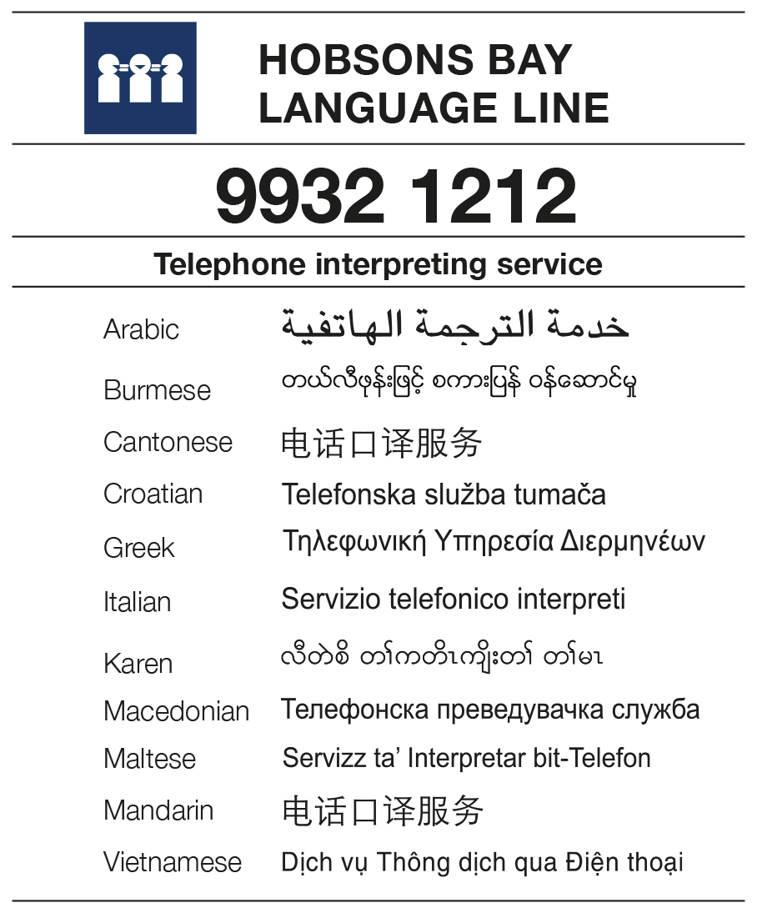

For further information or to have a copy of the draft Multicultural Policy 2016-20 in an alternate format contact Council (03) 9932 1000.

The terms people from culturally and linguistically diverse backgrounds and culturally and linguistically diverse communities are used throughout the Multicultural Policy 2016-20. These terms draw attention to the presence of multiple cultural and language groups in Hobsons Bay. The term cultural diversity will used in its broadest sense, and is inclusive of culture, language, race, faith and ethnicity differences. This approach is consistent with the Municipal Association of Victoria’s Statement of Commitment to Cultural Diversity. Other terms will be used to describe particular groups within culturally and linguistically diverse communities, including established communities, new and emerging communities and people from non-English speaking backgrounds.
Aboriginal and Torres Strait Islander people are an important part of Hobsons Bay’s cultural diversity. In 2011, Council adopted a Reconciliation Policy Statement which recognises the historical, social and cultural injustices inflicted on Indigenous people and the disadvantages which have resulted from these injustices. Given this specific focus on indigenous reconciliation, the needs of Aboriginal and Torres Strait Islander people are not specifically addressed within the Multicultural Policy 2016-20.
All data in this section is sourced from the 2011 Census of Population and Housing and Australian Government settlement records.
UNESCO/UNFPF/UNDP, Post-2015 Dialogues on Culture and Development, United Nations, Paris, pp.48-58

