Statement of Significance: Newport Civic and Commercial Heritage Precinct

Heritage Place: | Newport Civic and Commercial Heritage Precinct | PS ref no: | HO22

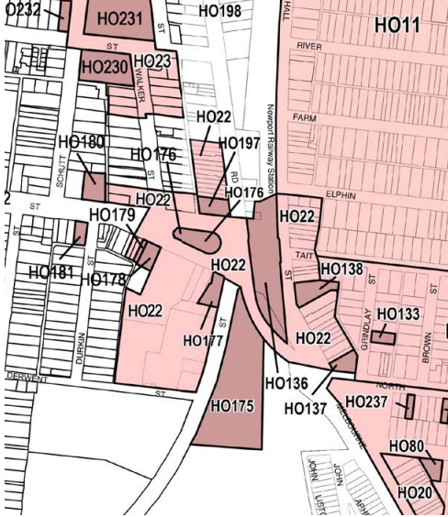
What is significant?
The Newport Civic and Commercial Heritage Precinct, which comprises all land in HO22, and includes the commercial precincts to the east and west of the Newport Railway Station, Newport. The area generally includes properties in Hall Street (part), Mason Street (part) and Melbourne Road (part), Newport.

How is it significant?
The Newport Civic and Commercial Heritage Precinct is of local historic, social and aesthetic significance to the City of Hobsons Bay.

Why is it significant?
Historically, it is significant as the major commercial centre within the Newport locality. It illustrates the nineteenth century beginnings of the area and the significant development that occurred from the Edwardian period up to WWII and into the early post-war period, which mirrors the residential and industrial growth of the area during the same periods. It also illustrates the close relationship between the development of the railways in this area and the development of the town of Newport. It is typical
of the civic and retail cores developed around railway stations as the rail network expanded through the late-nineteenth and early twentieth centuries.

These typically take the form of single and double-storey parapeted buildings constructed to front and side boundaries. These are representative of similar developments around railway stations throughout the metropolitan area.

Aesthetically, it is significant as a well-preserved late nineteenth and early twentieth century commercial precinct that is notable for its architectural landmark sites such as the former CBA bank, Newport Hotel and Masonic Hall but is characterised by more modest shops and commercial premises in Hall Street, Mason Street and Melbourne Road. It is presumed that the area is socially
significant for its strong associations with the Newport community as an important transportation hub and community meeting place.

The area is of interest for associations with early landholders such as William Hall and James Steele and Michael Durkin and public officials such as GA Paine and John Whitwam.

On this basis, the following places within HO22 contribute to the significance of the precinct.
- Hall Street, 1, 3-7, 9-10, 15-16, 18-21, 28, 30-32, 34-36, 38-40 and 42-46
- Mason Street, 1, 11-15, 17, 18 and 24-26
- Melbourne Road, 405-409, 413-431
- Market Street, 6 Newport Second Scout Hall and, 24-28 Newport RSL
- Bluestone kerb, channelling and laneways
- The Paine and Whitwam Reserves

Primary source
Inner Newport Heritage Gap Study 2022 (Lovell Chen and Hobsons Bay City Council)

Number | Address | Grade
1, 3-7, 9-10, 15-16, 18-21, 28, 30-32, 34-36, 38-40 and 42-46 | Hall Street | Contributory
1, 11-15, 17, 18 and 24-26 | Mason Street | Contributory
405-409, 413-431 | Melbourne Road | Contributory
6, 24-28 | Market Street - Newport Second Scout Hall and Newport RSL | Contributory
 | Bluestone kerb, channelling and laneways | Contributory
 | The Paine and Whitwam Reserves | Contributory

