Statement of Significance: Newport Estate Residential Heritage Precinct

Heritage Place: | Newport Estate Residential Heritage Precinct | PS ref no: | HO23

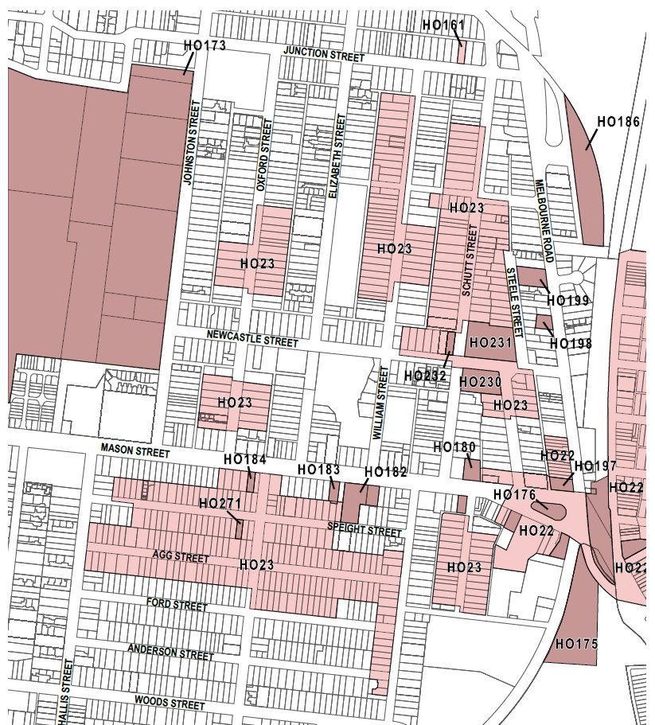

What is significant?
The Newport Estate Residential Heritage Precinct comprises all land in HO23. It consists of six discontiguous residential areas in which the original form and character of the area as developed from the 1880s to the end of WWII largely survives. Sub-precincts are located to the north and south of Mason Street.

How is it significant?
The Newport Estate Residential Heritage Precinct is of local historic and aesthetic significance to the City of Hobsons Bay.

Why is it significant?
Historically, it is significant for its strong associations with the development of Newport from the late Victorian era to the end of WWII. Numerous house allotments created during the 1880s boom period were often left vacant for a generation and the range of building styles present in confined areas illustrates the slow and sporadic growth in Newport. The layering of the area's history is illustrated in the early subdivision arrangements with early land boundaries preserved as roads such as Mason Street.

The area also retains associations with locally important individuals such as James Steele, Michael Durkin and C Williams. The predominantly weatherboard single-storey detached houses on small allotments underpins the working class origins of the area and the association with the railway workshops.

Aesthetically, it is significant for the groups of relatively intact examples of representative housing, from the Victorian, Federation and interwar periods up to the end of WWII. The built form is typical of residential development throughout Melbourne’s inner west during the late nineteenth and early to mid-twentieth centuries. On this basis, the following places within HO23 contribute to the significance of the precinct.

Primary source
Inner Newport Heritage Gap Study 2022 (Lovell Chen and Hobsons Bay City Council)

Number | Address | Grade
31-33, 41-45, 49-53, 57-73 and 30, 32, 36, 40, 50-56 | Schutt Street | Contributory
7-23 | Steele Street | Contributory
19-23 and 24-30 | Walker Street | Contributory
9 and 20-40 | Newcastle Street | Contributory
5-13 | Ross Street | Contributory
9, 17-19, 23-27, 35-47, 51, 53, 57-63, 67-71, 75-81, 85 and 91; and 2-14, 18-26, 30, 34-50, 54-90 | Agg Street | Contributory
81-93 | Mason Street | Contributory
19-53, 59, 61, 65-69, 73-75, 79 and 18-22, 26-32, 38-50, 54-56, 60, 66-68, 76, 82 | Speight Street | Contributory
3-13, 17-35 | Mirls Street | Contributory
14-30 and 34-40 | Ford Street | Contributory
1-15, 4-14, 33-41, 34-46 and 50-56 | Oxford Street | Contributory
35-55, 59-87, 91-99 and 40-54 | William Street | Contributory
10 | Ross Street | Contributory
3-11, 15-17, 23-29 and 2-4, 10-12, 16-18 and 22-4 | Durkin Street | Contributory

