Planning and Environment Act 1987

Hobsons Bay PLANNING SCHEME

AMENDMENT C88

EXPLANATORY REPORT

Who is the planning authority?
This amendment has been prepared by the Hobsons Bay City Council, which is the planning authority for this amendment.
The Amendment has been made at the request of ‘Precinct 15 landowners Consortium’ comprising the owners of some properties subject to the amendment.

Land affected by the Amendment
The Amendment applies to the land generally bounded by the West Gate Freeway, New Street, Blackshaws Road and Kyle Road in Altona North and South Kingsville.
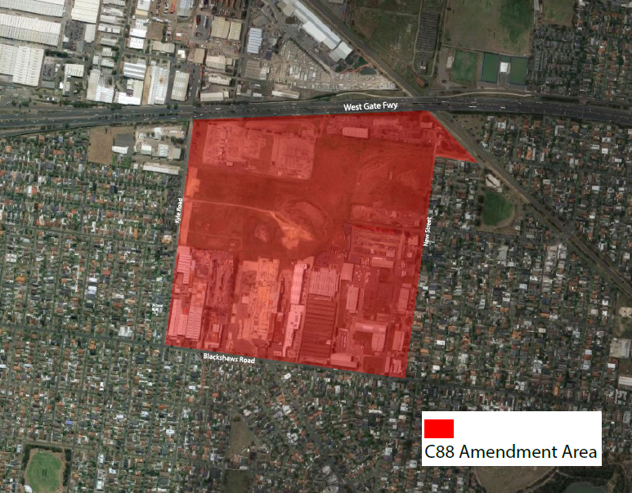

What the amendment does
Amendment C88 facilitates the replacement of part vacant and part occupied industrial land with a residential and mixed use development including provision for local shops and services, parks and offices.
Residential development is intended to be predominantly low rise, particularly at the edges of the site, with opportunities for mid-rise apartments and mixed use buildings in suitable locations within the site and on a short stretch of Blackshaws Road.
The amendment includes two incorporated plans to guide the layout of use and development and set out specific requirements for public streets, parks, landscaping, community facilities and service infrastructure.
The amendment:
- Implements relevant parts of the Hobsons Bay Industrial Land Use Strategy;
- Rezones the land from Industrial 1 Zone (IN1Z) and Industrial 3 Zone (IN3Z) to Comprehensive Development Zone (CDZ2) and except for the Brooklyn Terminal Station which is rezoned to Special Use Zone (SUZ6);
- Introduces Schedule 2 to Clause 37.02 Comprehensive Development Zone;
- Introduces Schedule 6 to the Special Use Zone;
- Applies the Development Contributions Plan Overlay (DCPO2) to the land;
- Introduces Schedule 2 to Clause 45.06 Development Contributions Plan Overlay
- Applies the Environmental Audit Overlay (EAO) to all but one property in the amendment area.
- Deletes the Heritage Overlay (HO166) from the former Gilbertson Meatworks site.
- Delete the entry for HO166 in the Schedule to Clause 43.01 Heritage Overlay.
- Inserts a new entry in the Schedule to Clause 52.01 requiring 9.2% of the land (or cash equivalent as relevant) to be contributed as public open space at subdivision.
- Inserts a new row in Schedule 4 to Clause 52.28 to prohibit gaming machines in the town centre.
- Includes maps 3DCPO and 4DCPO in the list of planning scheme maps at Clause 61.03.
- Incorporates the Altona North Comprehensive Development Plan June 2017 and the Altona North Development Contributions Plan June 2017 by listing them in the Schedule to Clause 81.01.

Strategic assessment of the Amendment

Why is the Amendment required?
A change in planning scheme zone is required to provide for use and development that is more suitable to the land’s current residential context. Industrial use of the land is no longer sustainable in the area in light of modern requirements for pollution control with regard to the close proximity of residential areas, and a local road network that is not suitable to the larger vehicles used in contemporary industry.
A development contributions plan is required in order to fairly distribute the cost of new infrastructure both between the new development and the existing community as well as between the varying sized landholdings in the amendment area.
An Environmental Audit Overlay is required to prevent establishment of new homes until such time as residual land contamination from historical industrial practices is remediated.
The Heritage Overlay on part of the land is redundant and should be removed.

How does the Amendment implement the objectives of planning in Victoria?
The amendment facilitates development in accordance with the objectives of planning in Victoria by:
- Distributing development rights in a fair manner across the amendment area.
- Providing for use and development that is more economic and sustainable with regard to the land’s location and context.
- Providing for the orderly arrangement of land use and development in the area and its orderly integration with the surrounding area.
- Providing a pleasant, efficient and safe living environment by including new local parks and well-connected streets with enough space for cars, pedestrians and cyclists and landscaping.
- Protecting the ability of the West Gate Freeway and adjacent rail line to continue operating unimpeded by requiring noise and vibration protection for new dwellings.
- Protecting the integrity of nearby gas and fuel transmission lines from any impacts of new use and development.
- Protecting the existing Melbourne Water main drain through the precinct and the currently disused fuel transmission line under Blackshaws Road from development and construction impacts.

How does the Amendment address any environmental, social and economic effects?
Potential contamination from industrial uses: The Environmental Audit Overlay is applied to all land which does not yet have a Certificate or Statement of Environmental Audit under the Environment Protection Act 1970. The overlay requires a Certificate or Statement of Environmental Audit to be issued before residential uses can commence.
Noise and vibration emissions from nearby rail and freeway operations and continuing industrial operations: New development must be laid out and constructed so as ameliorate noise, air and vibration emissions so not to unreasonably constrain the ongoing operation of the adjacent freeway, rail way and any continuing industrial operations in the amendment area and protect the amenity of new residents.
Water: the amendment requires land to be properly drained in accordance with the requirements of the drainage authority.
Environment: New development must provide landscaping of new public roads and other public spaces to ensure local climatic conditions are moderated. Properly formed footpaths and cycle paths connected to the existing network are also required to be constructed to provide options for non-motorised transport. Sustainable development practices are encouraged through requirements for sustainability management plans.
Economic effects: The rezoning of the land for a mix of urban uses will enable the land to be used and developed for its most economic use with regard to its strategic context. Provision is made for local shops, offices and other services within the precinct to allow for local scale economic activity and employment suitable to the site’s situation.
Social effects: The increase in the local population that the amendment will allow is accompanied by a financial contribution towards local infrastructure requirements from developers and new residents. The amendment is likely to provide for a more diverse social setting by bringing a greater mix of housing choice to the area including housing that is affordable to a greater range of households.

Does the Amendment address relevant bushfire risk?
There are no relevant bushfire risks in or around the amendment area.

Does the Amendment comply with the requirements of any Minister’s Direction applicable to the amendment?
Ministerial Direction - The Form and Content of Planning Schemes
The amendment is prepared and presented in accordance with the style guide and drafting instructions in the direction. The amendment only includes provisions from the VPPs.
Direction No. 1 Potentially Contaminated Land
As the land has been intensively use for industry and is proposed for residential use, the amendment applies the Environmental Audit Overlay to all land which does not yet have a Certificate or Statement of Environmental Audit under the Environment Protection Act 1970. The overlay requires a Certificate or Statement of Environmental Audit to be issued before residential uses can commence.
Direction No. 9 Metropolitan Strategy
The amendment has been prepared with regard to Plan Melbourne and in particular implements Plan Melbourne directions in the categories Housing Choice and affordability, Liveable communities and neighbourhoods, Environment and Water and Implementation: delivering better governance.
Direction No. 11 Strategic Assessment of Amendments
This explanatory report fulfils the requirements of this direction.
Preparation and Content and Reporting Requirements for Development Contributions Plans
The area may be subject to a development contributions plan as it is not in a scheduled development setting under the Preparation and Content and Reporting Requirements for Infrastructure Contributions Plans Ministerial Direction.
All items for which a levy is proposed in the development contributions plan are items that may be funded in accordance with this direction.

How does the Amendment support or implement the State Planning Policy Framework and any adopted State policy?
The amendment implements Plan Melbourne by:
- Providing for the mixed-use redevelopment of an exhausted industrial precinct in a location well suited to residential and mixed use development by virtue of its proximity to amenities, the transport network and employment opportunities.
- Designing the area to have convenient access to existing and future services and amenities in the area and to be properly integrated with the existing residential areas of Altona North.
- Streamlining approval processes by including plans with a resolved general layout for the area including primary land uses, critical street and trail networks and required infrastructure and construction standards.
- Facilitating a diversity of housing products to suit a range of household configurations and income levels.
- Requiring high standards in relation to the treatment of storm water and environmental building standards.
The amendment reflects the planning authority’s endeavour to integrate the range of policies relevant to the issues and balance conflicting objectives in favour of net community benefit and sustainable development, for the benefit of present and future generations.
The amendment addressed the range of relevant policy consideration throughout the State Planning Policy Framework as outlined throughout this explanatory report, the amendment itself and the amendment background report published with the amendment.

How does the Amendment support or implement the Local Planning Policy Framework, and specifically the Municipal Strategic Statement?
Of particular relevance, the Hobsons Bay Municipal Strategic Statement (‘the MSS’) identifies the amendment area as a ‘strategic redevelopment area’ which the MSS directs to be transitioned to accommodate urban growth.
In line with the MSS the amendment proposes a resolved and comprehensive plan that addresses the issues relevant to this area including:
- Land contamination through application of the Environmental Audit Overlay.
- Land use designation through acknowledging the overwhelmingly residential context of the site and the access to services, transport and amenities suitable for residential use, infrastructure requirements including a proper street network, connections to surrounding arterial roads, public transport services and walk/cycle trials.
- Potential off site impacts including ensuring that new development does not impact on operation of adjacent major road, rail and transmission infrastructure.
- Traffic management in and around the area including requirements for the provision of a new road network within the site that is logically connected to the existing road network with safe signalised intersections.
- Staging of development that ensures fair and timely development opportunities across the area.
- Protection of ongoing viable industries from encroaching sensitive uses through siting and construction requirements.
- The future character of the area, the potential impact on neighbouring residential character and the potential interface issues with adjoining land uses including managing the location and scale of building in relation to existing residences facing the site.
- Social impacts including provision for a range of housing options to ensure access to homes for a range of household types, centrally located new community facilities and local retail, commercial and leisure services.
- Incorporation of Environmentally Sustainable Design principles through thoughtful layout of the road and trail network, landscaping provisions to assist with local climate conditions, provision for significant amounts of open space and requirement for sustainability management plans for new buildings.
- Diversity in housing choice including affordable housing and the provision for a range of dwelling types from conventional detached housing to apartment living.
- Zoning and planning controls that ensure each site is considered with regard to the proper integration of whole area.

Does the Amendment make proper use of the Victoria Planning Provisions?
The amendment uses various standard local provisions from the Victoria Planning Provisions in the manner set out the Act and the relevant ministerial direction.

How does the Amendment address the views of any relevant agency?
Where appropriate, the amendment has incorporated recommendations from the EPA in relation to land remediation, Melbourne Water in relation to drainage assets on the land, Public Transport Victoria in relation to adjacent and future bus and rail networks, VicRoads in relation to the arterial road network and licensees of nearby fuel transmission pipelines.

Does the Amendment address relevant requirements of the Transport Integration Act 2010?
The amendment is likely to have a significant impact on the transport system at a local level. It will require new connection to the regional road network at Blackshaws Road and provides for the creation of a new local road network that will set the future pattern of development in the precinct. It will allow the development of a bus network in the area and create demand for public transport services.
The proposed additions and changes to the existing transport system in and adjacent to the precinct will meet the transport system objectives by:
- Providing for an interconnected road system that responds to the likely level of use generated by the precinct and hence facilitating investment in housing and local retail services in the area.
- Enabling efficient access to existing and planned employment and services in and around Altona North, and the broader region, through direct connections to the arterial road network and bus and train services.
- Providing locally based sports, recreational, community and retail facilities to reduce the need for extended travel.
- Designing roads that are of a suitable scale, are compatible with the expected travel demand.
- Providing for the efficient construction of infrastructure items concurrent with works associated with subdivision development.
- Integrating relevant government bodies involved in the provision of transport infrastructure and services in the decision making process of future planning permit applications.
- Protecting the ongoing operation of freeway and rail services in the area through protecting against noise and vibration from these services.
- Recognising planning for the Western Distributor.

Resource and administrative costs

What impact will the new planning provisions have on the resource and administrative costs of the responsible authority?
The planning provisions will require a moderate level of administration by the responsible authority. No intervening plans are required before permit applications can be considered, which will reduce the administrative burden. The amendment implements a resolved structure plan and development contributions plan for the area. In most cases this will obviate the need for further notification of individual permit applications but require more intensive scrutiny of each application. However the comprehensive and integrated nature of the provisions will ensure that development of each parcel of land should require only one major permit application to enable development.

Where you may inspect this Amendment
The Amendment is available for public inspection, free of charge, during office hours at the following places:

Hobsons Bay City Council Altona North Library
Hobsons Bay Civic Centre 180 Millers Road
115 Civic Parade ALTONA NORTH VIC 3025
ALTONA VIC 3018

Altona Library Newport Library
123 Queen Street 13 Mason Street
ALTONA VIC 3018 NEWPORT VIC 3015

Altona Meadows Library Williamstown Library
1-23 Central Avenue 104 Ferguson Street
ALTONA MEADOWS VIC 3028 WILLIAMSTOWN VIC 3016

The Amendment can also be inspected free of charge at the Department of Environment, Land, Water and Planning website at www.delwp.vic.gov.au/public-inspection.

Submissions
Any person who may be affected by the Amendment may make a submission to the planning authority. Submissions about the Amendment must be received by 1 September 2017.
A submission must be sent to: Hobsons Bay City Council, PO Box 21, Altona, 3018.

Panel hearing dates
In accordance with clause 4(2) of Ministerial Direction No.15 the following panel hearing dates have been set for this amendment:
- directions hearing: Week beginning 9 October 2017.
- panel hearing: Week beginning 13 November 2017.

